Chap 4 Programming Exercises Tyler Paulley

Exercise 5: Fibonacci

Register Values during Execution

Starting with 0 and 1, we can see that 1, 2, 3, 5, and 8 are the remaining values in the first 7 numbers of the Fibonacci sequence by looking at register EAX.

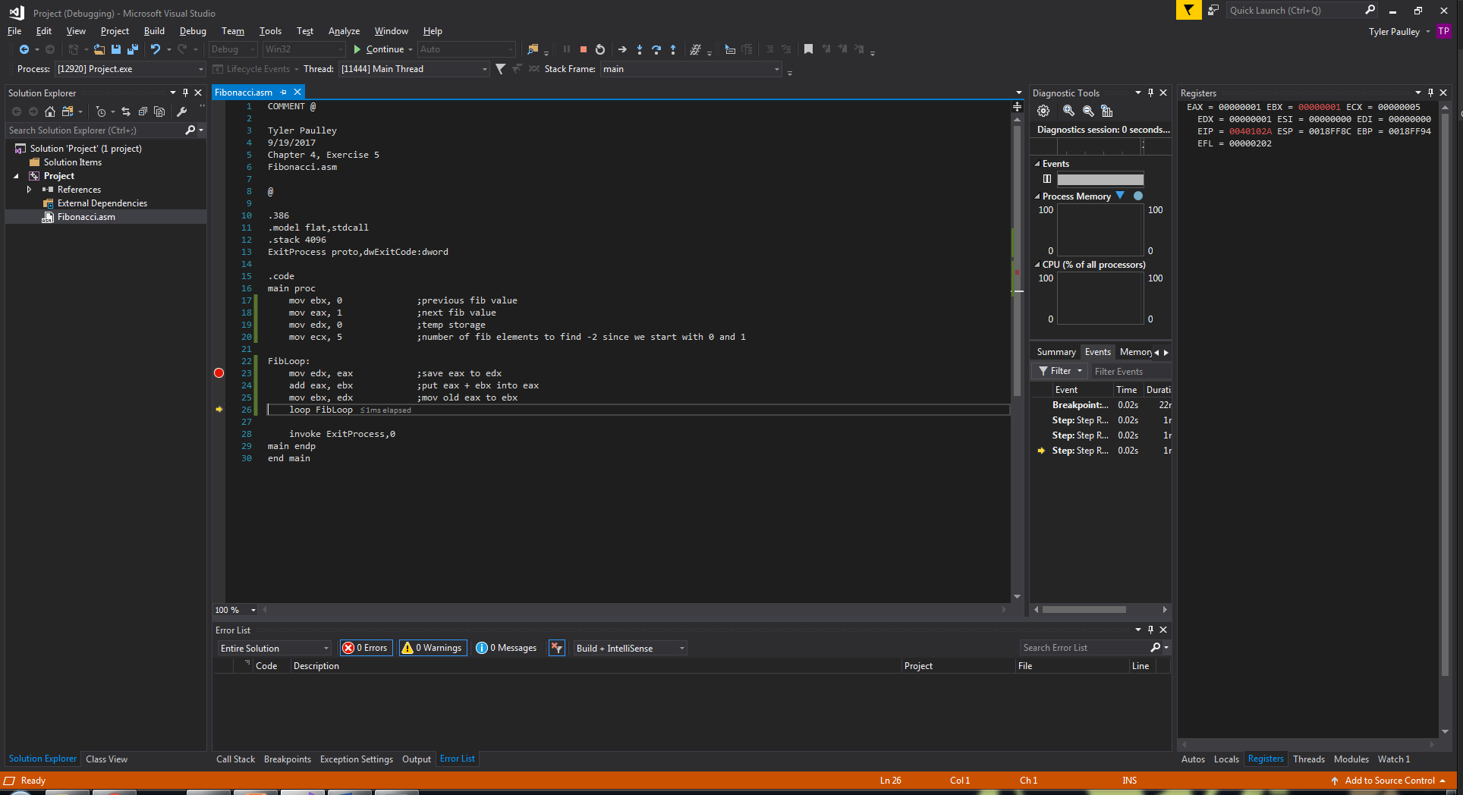

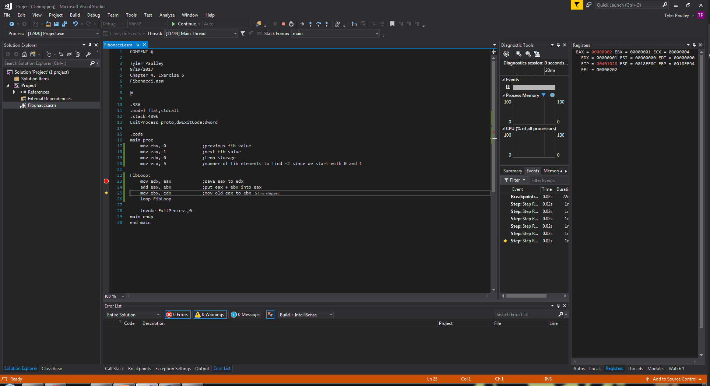

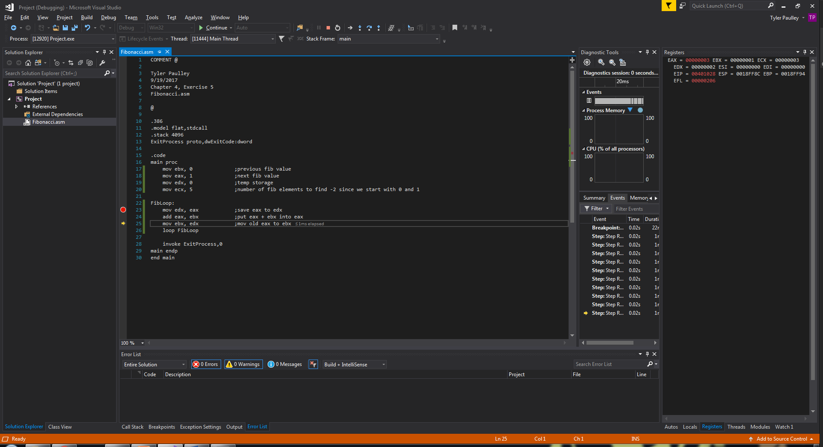

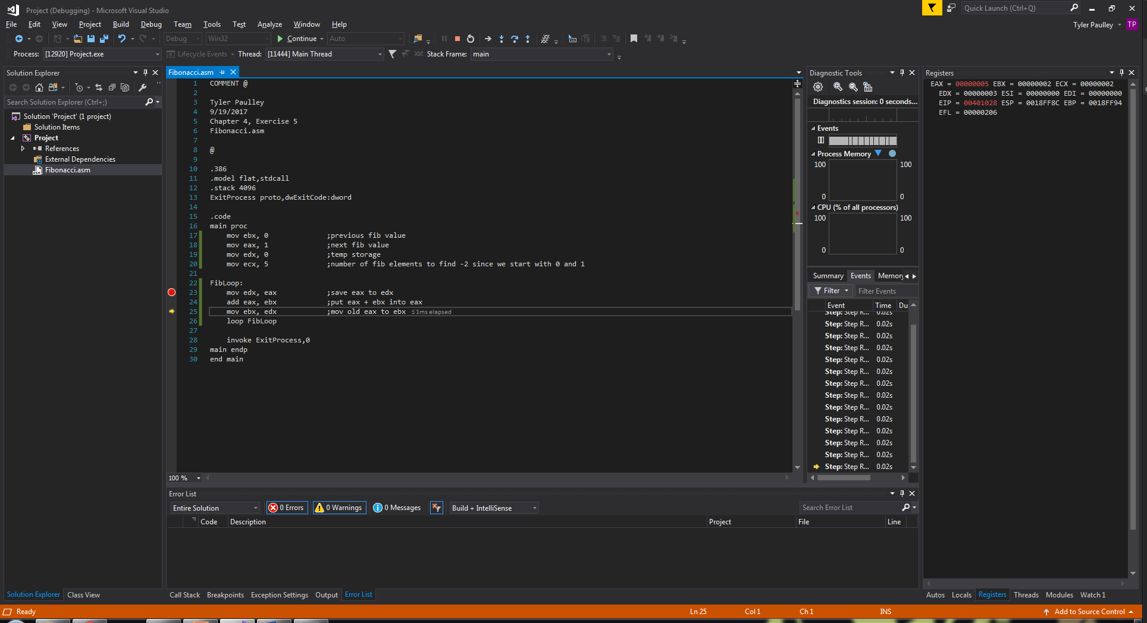

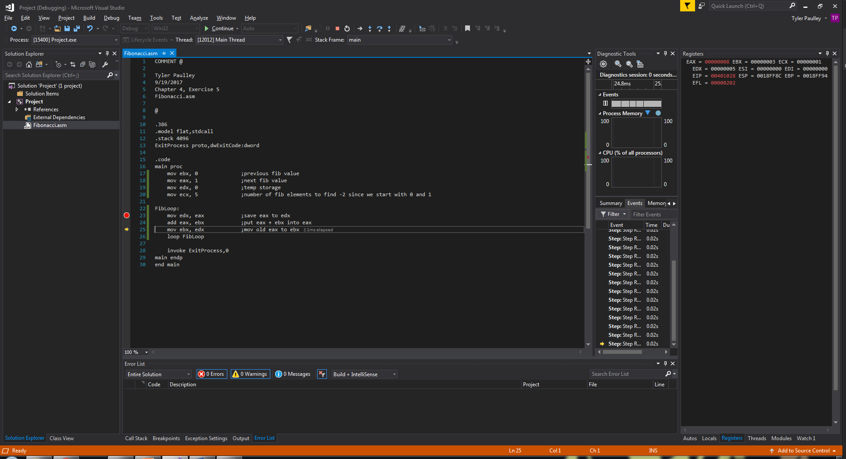

Exercise 6: Reverse Array

Values during Execution

ESI stores the address of the start of the array, EDI is the address of the last element.

The array begins at location 0x00404000

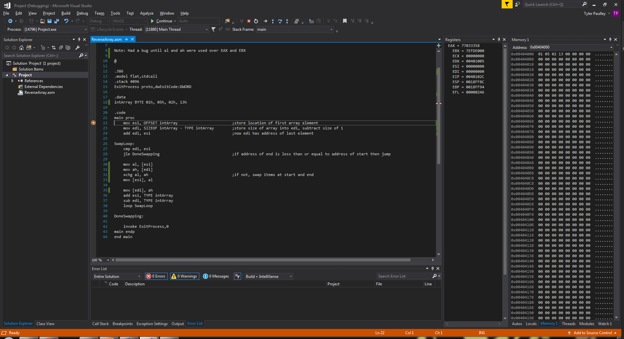

After running we can see that the order has reversed. At the start is was 1 – 5 – 2 – 13 now it is 13 – 2 – 5 – 1

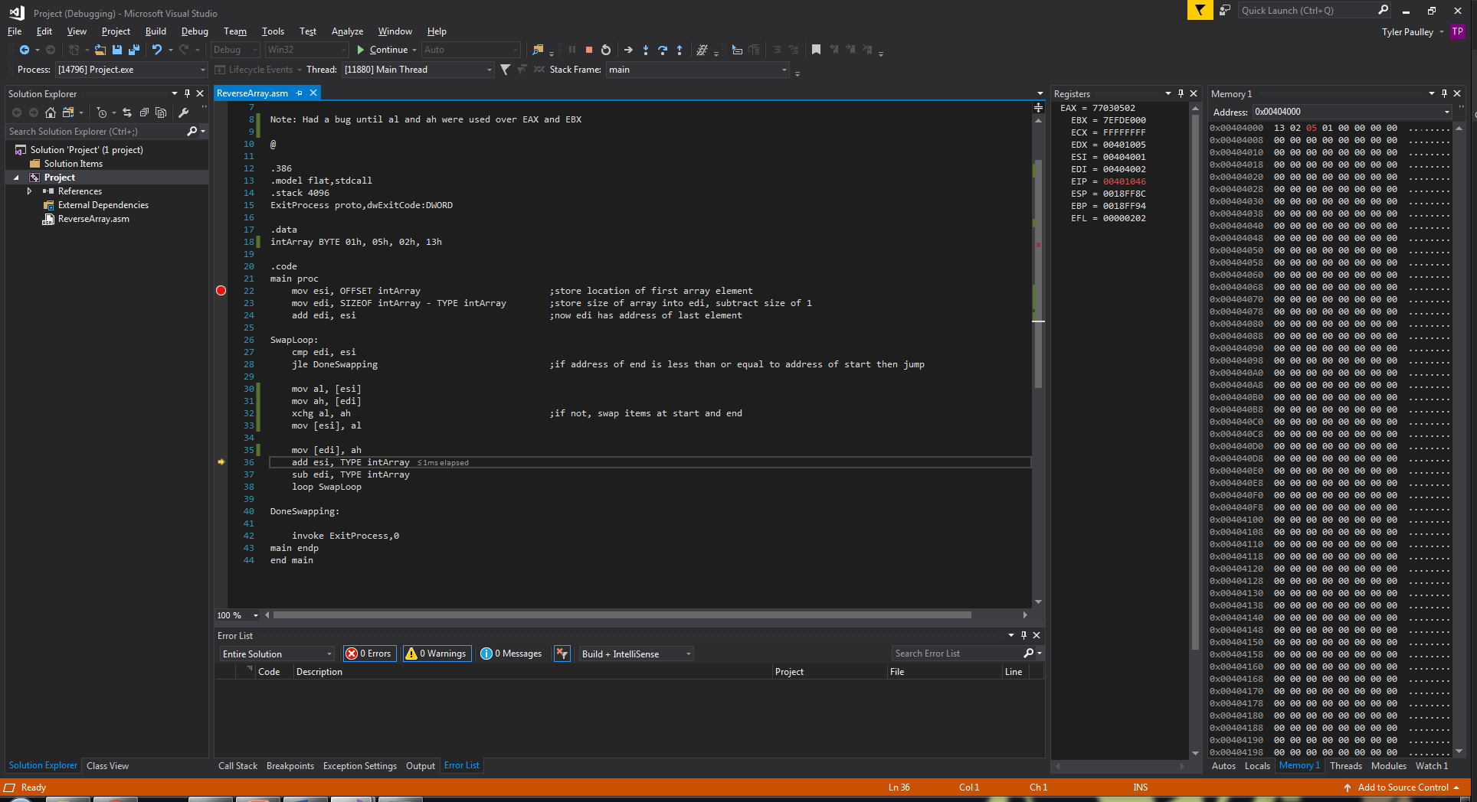

Exercise 7: Copy String in Reverse

Values during Execution

The below image is the beginning of the program. As we can see, the source string starts at memory location 0x00404000. We hope to copy it in reverse starting at the location with the first # character.

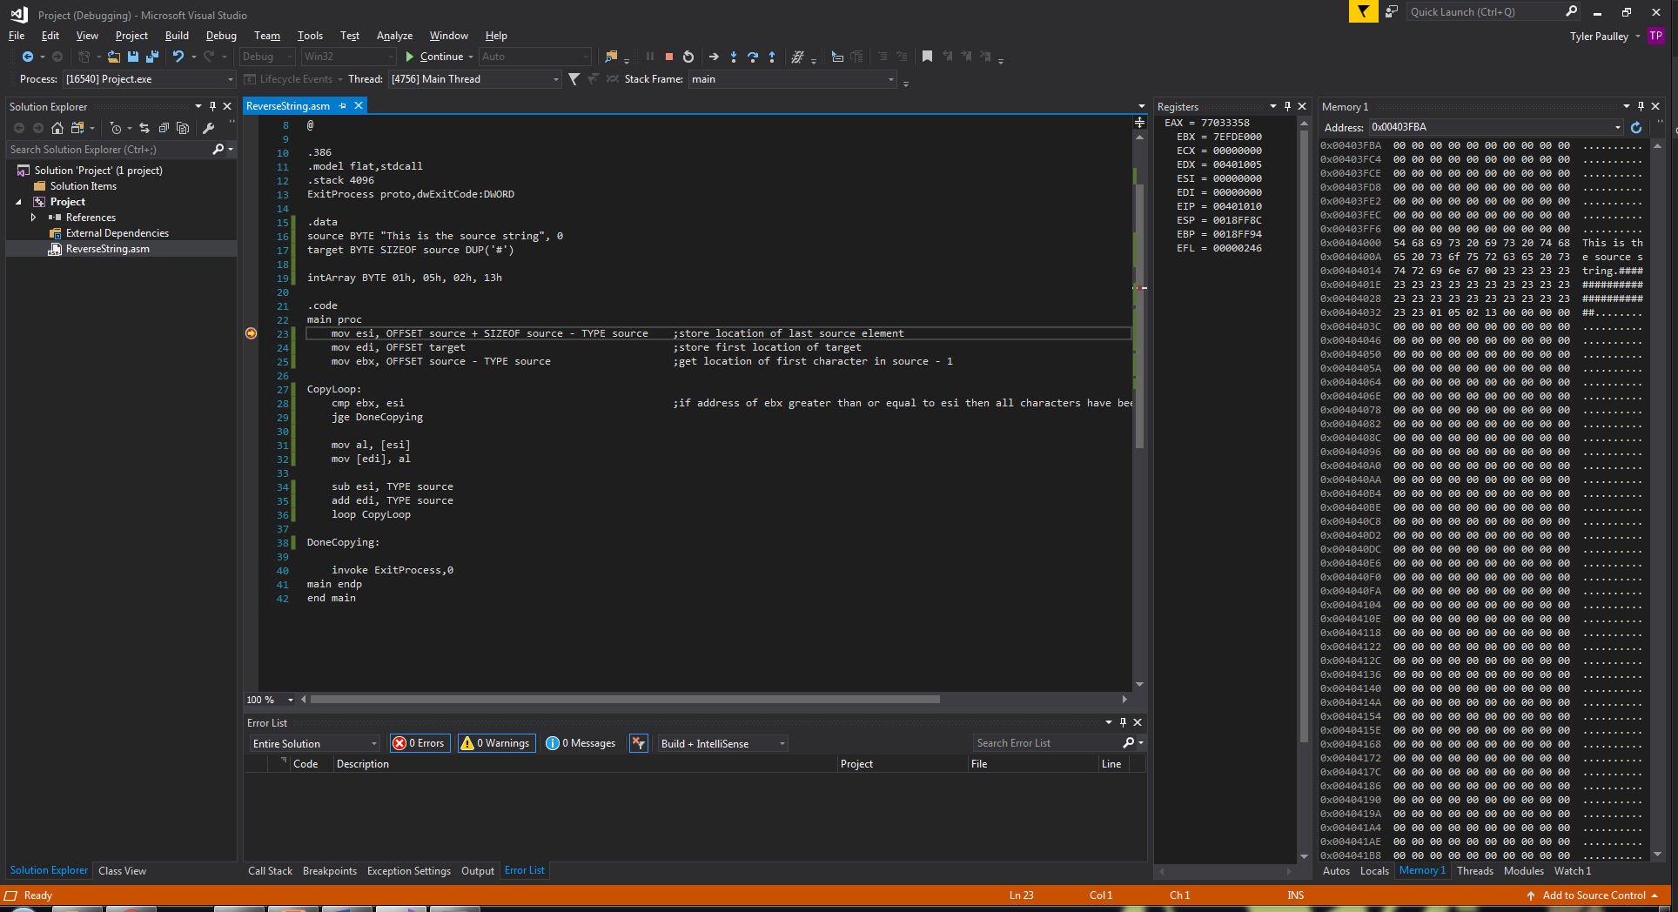

After the program is finished, we can see that the string has successfully been copied in reverse to the addresses occupied by the variable ‘target’.

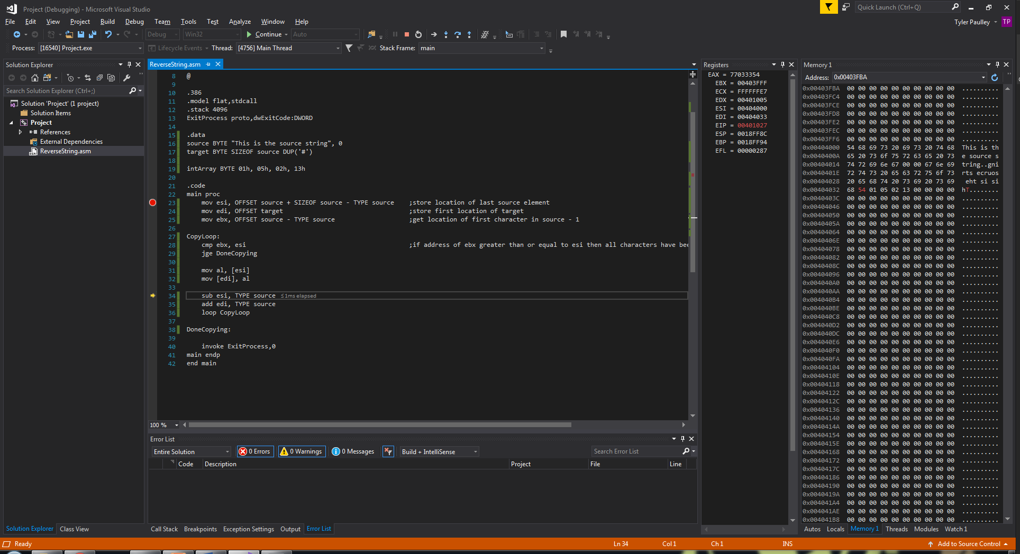

Exercise 8: Shifting Array Elements

Values during Execution

I used the decimal values of 10, 20, 30 and 40 for my array. As we can see, after execution the values have shifted by one position to the right.

